Rich Fox
ITAI 2372
June 20, 2026

AI in Fraud Detection: A Case Study of HSBC

Introduction
HSBC (The Hongkong and Shanghai Banking Corporation) is one of the world’s largest banking and financial services organizations. Founded in 1865 to finance trade between Europe and Asia, HSBC is now Europe’s largest bank by assets and serves millions of personal and corporate clients across dozens of countries (HSBC, n.d.-a). The bank has integrated artificial intelligence into more than 600 applications to strengthen operational efficiency, curb financial crime, personalize the customer experience, and increase employee productivity (HSBC, n.d.-b).
AI’s importance in combating fraud is best illustrated by HSBC’s shift away from static, rule-based screening toward a dynamic, AI-driven infrastructure known as the Dynamic Risk Assessment (DRA) platform. While traditional methods rely on predetermined rules that criminals can learn to circumvent, HSBC’s system uses machine learning to analyze more than one billion transactions every month, allowing the bank to detect two to four times more suspicious activity than its previous approach (Chief AI Officer, 2026). By continuously processing transaction amounts, timing, and geographic data, the AI updates its understanding of criminal behavior in real time, catching sophisticated illicit activity that rule-based systems routinely miss.

Technology Overview
At the center of HSBC’s fraud-prevention strategy is the Dynamic Risk Assessment (DRA) platform, developed in partnership with Google. The DRA processes over one billion transactions monthly, using machine learning to evaluate transaction amount, timing, geography, and behavioral indicators simultaneously. Rather than relying on fixed rules that criminals can learn to avoid, the platform recognizes contextual risk signals and anomalies in individual customer behavior, allowing it to separate genuine threats from legitimate activity with far greater accuracy than HSBC’s previous methods (Chief AI Officer, 2026).
HSBC pairs this transaction-level analysis with network intelligence and behavioral pattern recognition to identify coordinated criminal organizations rather than isolated suspicious transactions. The bank’s integration of the Quantexa Decision Intelligence platform reveals hidden links between accounts and entities that would be nearly impossible for human investigators to uncover manually, allowing HSBC to move from reacting to individual transactions toward proactively disrupting entire criminal networks and money-laundering operations (Chief AI Officer, 2026).
Because financial institutions operate under close regulatory scrutiny, HSBC also relies on Explainable AI (XAI) to keep its decision-making transparent. XAI provides auditable reasoning for every flag the system generates, ensuring outcomes can be reviewed by regulators and, when necessary, used as evidence in legal proceedings. The bank further automates the generation of Suspicious Activity Reports (SARs), giving law enforcement timely, well-documented intelligence to support investigations and prosecutions (Chief AI Officer, 2026).

Benefits
Transitioning to a dynamic AI infrastructure has produced measurable improvements in HSBC’s fraud detection capabilities. The bank now detects two to four times more suspicious activity than it did under its previous rule-based approach, and that improved sensitivity comes paired with a 60% reduction in false positives, easing the investigative burden on compliance teams and preventing legitimate transactions from being needlessly delayed. Investigation timelines that once took several weeks now take only a few days, allowing HSBC to intercept suspicious funds before they move beyond recovery and shifting the bank’s posture from reactive to proactive (Chief AI Officer, 2026).
Beyond these detection metrics, the AI integration delivers strategic value through network intelligence and behavioral analysis. By surfacing hidden links between seemingly unrelated accounts, HSBC can disrupt entire coordinated criminal networks rather than chasing isolated transactions. The reduced false-positive rate also improves the customer experience by minimizing the friction of manual compliance reviews, while automation of routine screening frees compliance staff to focus on complex investigations that require human judgment and creativity. Explainable AI further reinforces these gains by keeping every automated decision transparent and auditable, building regulatory confidence and protecting business value as the bank pursues continued growth (Chief AI Officer, 2026).
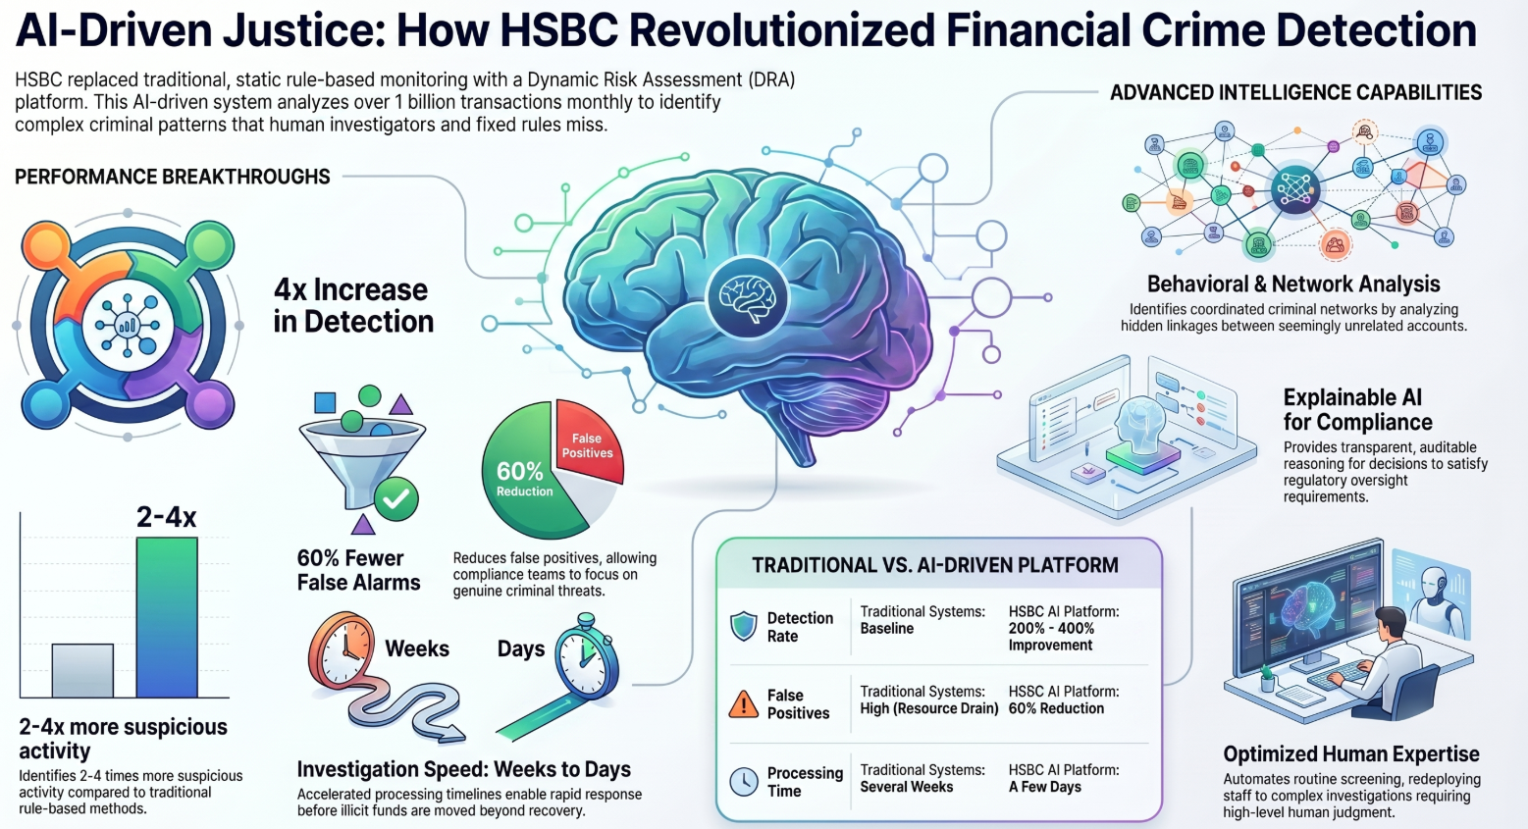

Challenges

Strategic and Leadership Hurdles
One of HSBC’s biggest hurdles was simply the leadership decision to change course — a move many banking executives are reluctant to make. Abandoning a familiar, static rule-based model for a dynamic AI system required a complete shift in institutional philosophy. Rather than pursuing incremental upgrades, HSBC committed to a comprehensive strategic transformation built around clear competitive goals, including stopping financial crime before losses occur and establishing sustainable, adaptive intelligence (Chief AI Officer, 2026).

Operational and Workflow Changes
The shift to AI-driven detection also required HSBC to rebuild its transaction monitoring, investigation, and compliance workflows from the ground up. Traditional fraud detection depends on fixed rules and manual review of every flagged transaction; integrating AI meant redesigning these processes so the technology could handle more than one billion transactions a month while still making effective use of human investigators. Staff had to be redeployed from routine screening toward complex investigations requiring expertise, creativity, and strategic thinking — skills AI cannot replicate (Chief AI Officer, 2026).

Technical Limitations and the Human-AI Balance
AI alone cannot manage every part of a criminal investigation. Tasks such as detailed analysis, interviewing, and strategic judgment still depend on human experts, so HSBC had to design a framework in which AI augments rather than replaces that expertise. This also explains why competitors struggle to replicate HSBC’s results: matching this approach demands a substantial investment in technology infrastructure and process redesign that is difficult to achieve within legacy banking environments (Chief AI Officer, 2026).

Regulatory and Transparency Requirements
Operating in a heavily regulated industry, HSBC had to solve the problem of AI “black boxes.” The bank’s use of Explainable AI provides auditable, transparent reasoning behind every flag, which is essential for maintaining regulatory confidence and ensuring outcomes can be validated by oversight bodies or used as evidence in legal proceedings. HSBC also had to uphold consistent standards for responsible, ethical AI deployment across its more than 600 use cases to sustain long-term trust (Chief AI Officer, 2026).

Conclusion
HSBC’s implementation of AI-driven fraud detection illustrates a broader shift in the banking industry: away from reactive, rule-based screening and toward proactive, adaptive systems built on continuous machine learning and behavioral analysis. The research points to several key findings.
First, the performance gains have been substantial. HSBC now detects two to four times more suspicious activity than it did under its previous methods, alongside a 60% reduction in false positives that reduces customer friction and lets compliance teams focus on genuine threats. Second, the system has dramatically improved operational speed, cutting investigation timelines from several weeks to a few days and enabling the bank to intercept suspicious funds before they disappear. Third, the DRA platform’s ability to process over one billion transactions monthly — combined with Quantexa’s network intelligence — allows HSBC to uncover entire criminal organizations rather than isolated incidents. Fourth, automation of routine screening and SAR generation has let the bank redeploy its workforce toward the sophisticated investigative work that AI cannot perform. Finally, Explainable AI keeps the entire system transparent and auditable, satisfying regulators while protecting the bank’s competitive position (Chief AI Officer, 2026).
For institutions considering a similar path, the HSBC case suggests several recommendations. Leadership should treat the move from static to dynamic, adaptive detection as a strategic commitment rather than an incremental upgrade, with success measured by concrete outcomes — fewer losses, faster investigations, and fewer false positives — rather than by technology adoption alone. Institutions should prioritize behavioral analysis and network intelligence over isolated transaction screening, since modern financial crime is defined by coordinated, relational schemes rather than one-off transactions; this requires real investment in infrastructure capable of processing billions of transactions with high accuracy. Operationally, AI should be positioned to augment human investigators, not replace them, freeing skilled staff for the judgment-driven work AI cannot do. Finally, Explainable AI should be treated as a requirement rather than an afterthought, ensuring every automated decision remains transparent enough to satisfy regulators and hold up in legal proceedings. Together, these steps let AI-driven fraud detection protect business value while supporting sustainable growth (Chief AI Officer, 2026).

References
Chief AI Officer. (2026). How HSBC’s AI catches 4x more financial criminals while cutting false alarms by 60%. https://chiefaiofficer.com/how-hsbcs-ai-catches-4x-more-financial-criminals-while-cutting-false-alarms-by-60/
HSBC. (n.d.-a). Our history. HSBC. Retrieved June 20, 2026, from https://www.hsbc.com/who-we-are/our-strategy-and-values/our-history
HSBC. (n.d.-b). Transforming HSBC with AI. HSBC. Retrieved June 20, 2026, from https://www.hsbc.com/who-we-are/hsbc-and-digital/hsbc-and-ai/transforming-hsbc-with-ai
HSBC. (2026). HSBC and Google Cloud announce transformative AI banking partnership [Press release]. https://www.hsbc.com/news-and-views/news/media-releases/2026/hsbc-and-google-cloud-announce-transformative-ai-banking-partnership

